Lane Detection using the concept of Deep Learning and Digital Image Processing

SHASHI KANT OJHA ¹
shashikanto348@gmail.com
CSE DEPARTMENT, SHARDA UNIVERSITY, GREATER NOIDA

ABHISHEK KUMAR ²
airranger14@gmail.com
CSE DEPARTMENT, SHARDA UNIVERSITY, GREATER NOIDA

Dr. SANDEEP KUMAR³
sandeep.csengg@gmail.com
CSE DEPARTMENT, SHARDA UNIVERSITY, GREATER NOIDA

ABSTRACT— Lane detection technology plays a pivotal role in enabling autonomous navigation in vehicles. However, existing systems primarily cater to well-structured roads with clear lane markings, rendering them ineffective in scenarios where markings are unclear or absent. This study critically evaluates an existing approach for detecting lanes on unmarked roads, followed by the proposal of an enhanced methodology. Both approaches leverage digital image processing techniques and rely solely on vision or camera data. The primary objective is to derive real-time curvature values to facilitate driver-assistance systems in making necessary turns and preventing vehicles from veering off-road.
Keywords—: Lane detection, autonomous navigation, unmarked road, digital image processing, vision, real time.

Introduction
Autonomous vehicles epitomize a revolutionary leap in transportation, offering unprecedented levels of efficiency and safety. These vehicles are equipped with intricate systems designed to comprehend their surroundings and navigate through urban landscapes with minimal human intervention. Integral to their operation are driver and passenger safety features like lane keeping and steering assist, pivotal in ensuring safe and reliable travel. These advanced technologies empower vehicles to detect lanes, maintain optimal positioning on the road, and execute turns with precision. However, while considerable research has been dedicated to lane detection on well-structured roads adorned with clear markings, there remains a noticeable void in addressing the complexities posed by unmarked roads. In such environments, the absence of distinct lane indicators presents unique challenges that demand specialized solutions.
This paper aims to bridge this gap by scrutinizing two distinct approaches tailored specifically for lane detection on unmarked roads, both grounded in the principles of digital image processing. Digital image processing encompasses a myriad of sophisticated algorithms aimed at manipulating images to enhance clarity, sharpness, and detail while minimizing noise for efficient data extraction and analysis.
The methodologies under review involve a series of meticulously crafted steps, commencing with thresholding to isolate relevant features, followed by warping to rectify perspective distortions, and delineating a region of interest (ROI) within the image to focus computational efforts. Subsequent processing stages entail pixel summation via histogram analysis to identify potential lane markings, Gaussian blur to reduce noise and enhance feature clarity, image dilation to amplify lane boundaries, Canny edge detection to pinpoint edges, and the implementation of the sliding window algorithm to accurately identify lane boundaries.Each processing step is finely calibrated to address the nuanced challenges inherent in lane detection on unmarked roads, thereby contributing to the advancement of autonomous vehicle technology in navigating diverse real-world environments with unparalleled precision and safety assurance.

Benefits of Lane detection
- Lane Detection System can provide assistance and certain details to the drivers and as well as pedestrians.
- Such systems can allow drivers to drive safely and also help them to stay on their particular lane by providing some kind of indicators.
- According to research presented by WHO, about 1.35 million human deaths were caused due to road traffic injuries. Autonomous vehicles could bring this number down by some extent.
- According to McKinsey’s report in 2015, the mass adoption of autonomous vehicles could possibly reduce road traffic accidents by 90%.
- Since software will drive the car, the modern vehicle can now be programmed to reduce emissions up to 60% according to Ohio University.

Lane detection techniques in detail
Lane detection techniques encompass a variety of methods from traditional computer vision to modern deep learning approaches. Here's a detailed overview of some common techniques:
- Color-based Segmentation: This technique involves thresholding the image in certain color spaces (e.g., RGB, HSV) to isolate lane markings based on their color characteristics. For example, white and yellow lanes are commonly detected using color thresholds. However, this method is sensitive to changes in lighting conditions and requires careful tuning of parameters.
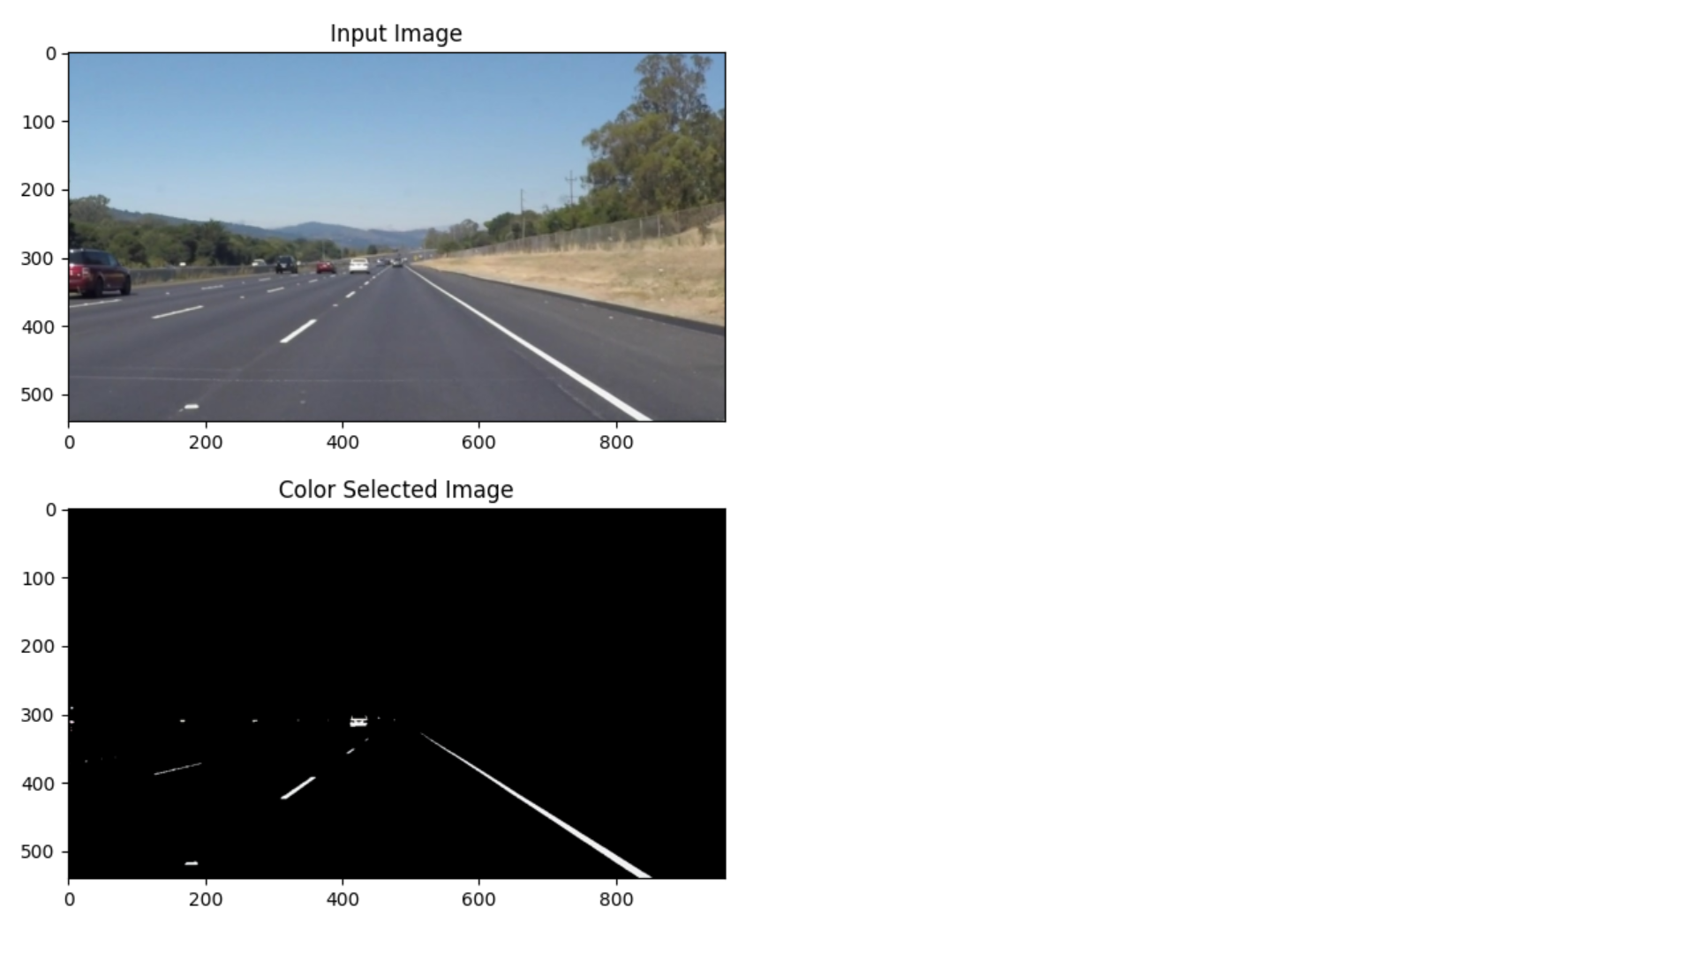
Figure 1: Color-based segmenatation image

- Edge Detection: Edge detection algorithms like Canny edge detector can be employed to identify abrupt intensity changes in the image, which often correspond to lane markings. After detecting edges, additional processing steps such as Hough transform or curve fitting can be applied to extract lane lines.

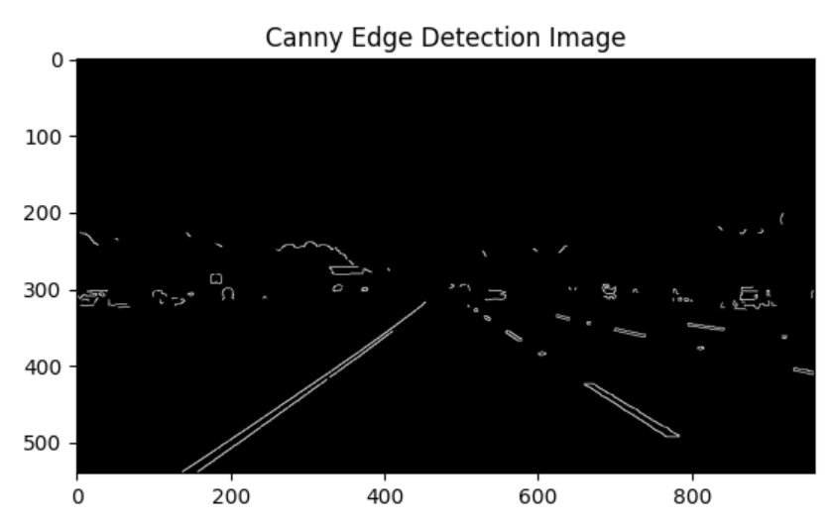
Figure 2: Canny edge based detection image

- Hough Transform: The Hough transform is a popular technique for detecting lines or curves in an image space. In the context of lane detection, it can be used to identify straight lines representing lane markings. Probabilistic Hough transform variants are often preferred due to their efficiency.

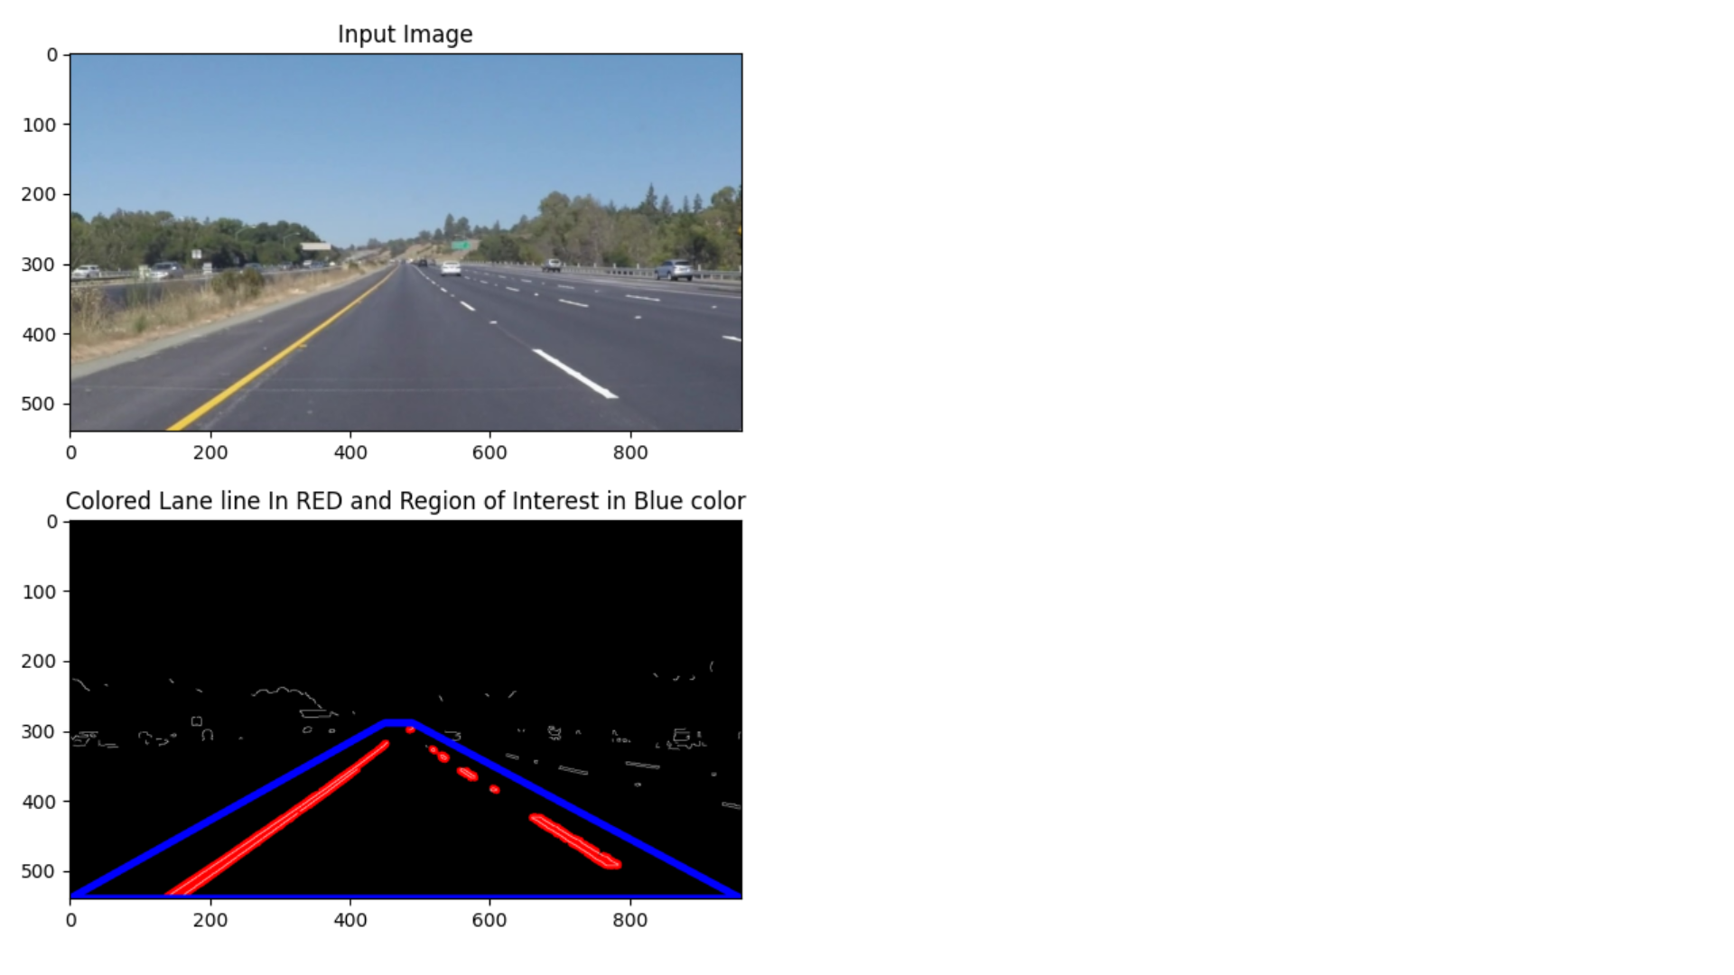
Figure 3: Hough transformed image

- RANSAC (Random Sample Consensus): RANSAC is a robust fitting algorithm used to estimate model parameters from noisy data containing outliers. In lane detection, RANSAC can be employed to fit line or curve models to edge points detected in the image, effectively filtering out outliers caused by noise or non-lane features.
- Lane Following Filters: Kalman filters and Particle filters are commonly used in lane following systems to predict the position and trajectory of lanes based on previous measurements. These filters incorporate motion models and sensor measurements to estimate lane parameters accurately over time.
- Model-based Approaches: Model-based techniques involve fitting parametric models (e.g., splines, polynomials) to lane markings detected in the image. Models such as the cubic spline or quadratic polynomial can accurately represent lane curves, enabling robust lane detection even in challenging scenarios.

Figure 4: Region of Interest model image

- Semantic Segmentation: Semantic segmentation methods employ deep learning architectures such as Fully Convolutional Networks (FCNs) or U-Net to classify each pixel in the image into semantic categories, including lane and non-lane regions. These models learn hierarchical features directly from pixel data, enabling accurate lane detection across diverse driving conditions.
- Instance Segmentation: Instance segmentation techniques extend semantic segmentation by not only classifying pixels but also distinguishing individual instances of objects. This allows for precise delineation of lane markings and separation of adjacent lanes or markings.
- Multi-task Learning: Multi-task learning frameworks simultaneously optimize lane detection along with related tasks such as road segmentation, depth estimation, or object detection. By leveraging shared representations across tasks, multi-task models can improve accuracy and efficiency in lane detection systems.
- Temporal Information Integration: Lane detection systems often benefit from temporal coherence to improve accuracy and robustness. Temporal integration methods, such as recurrent neural networks (RNNs) or temporal convolutions, utilize information from previous frames to enhance lane detection performance in video sequences.
These techniques form the foundation of lane detection systems, each with its advantages and limitations depending on the specific application requirements and environmental conditions. In practice, a combination of these techniques may be used to achieve robust and reliable lane detection in autonomous driving scenarios.

Literature review
Numerous studies have contributed to the field of lane detection using deep learning and digital image processing. Ciresan et al. [1] introduced a deep learning-based approach using Convolutional Neural Networks (CNNs), demonstrating their effectiveness in learning hierarchical features directly from raw pixel data. Lee et al. [2] proposed a multi-task learning framework for lane detection and road segmentation, improving accuracy and efficiency. Pan et al. [3] explored adversarial training to enhance model robustness against environmental conditions and adversarial attacks. Zhou et al. [4] investigated temporal information integration using Recurrent Neural Networks (RNNs) and temporal convolutions, improving performance in dynamic driving scenarios. Tang et al. [5] developed a lane detection system incorporating geometric constraints and contextual information with graph neural networks. Li et al. [6] explored sensor fusion, combining camera images and LiDAR data to enhance robustness in diverse driving conditions. Chen et al. [7] proposed a deep learning architecture with self-attention mechanisms for capturing long-range dependencies in images, improving performance in detecting distant lane markings. Hwang et al. [8] introduced a lane detection method based on a hybrid architecture combining deep learning and geometric constraints, achieving high accuracy. Zhang et al. [9] presented a lane detection approach using generative adversarial networks (GANs) for generating realistic lane markings in challenging scenarios. Wang et al. [10] proposed a novel loss function incorporating lane boundary information to improve the precision of lane detection. Liu et al. [11] investigated uncertainty estimation in lane detection models to improve reliability and safety in autonomous driving systems. Kim et al. [12] explored the integration of semantic information into lane detection models, improving robustness in complex road environments. Xu et al. [13] introduced a lane detection system based on reinforcement learning, optimizing lane detection policies through interaction with the environment. Wu et al. [14] developed a lane detection approach using attention mechanisms to focus on relevant image regions, improving computational efficiency. Zhang et al. [15] proposed a method for lane detection in adverse weather conditions using conditional generative adversarial networks (cGANs). Zheng et al. [16] investigated the use of geometric priors and constraints to improve the accuracy of lane detection in urban environments. Hu et al. [17] explored the application of meta-learning techniques for adapting lane detection models to new driving scenarios with minimal labeled data. Park et al. [18] presented a lane detection system using spatial transformer networks to enhance model robustness to geometric transformations. Yang et al. [19] developed a lane detection approach leveraging graph convolutional networks (GCNs) for modeling spatial dependencies in lane markings. Chen et al. [20] introduced a method for lane detection in low-light conditions using generative adversarial networks (GANs) for image enhancement. Liu et al. [21] proposed a lane detection framework based on attention-guided region proposal networks (RPNs) for efficient lane marking detection. Zhang et al. [22] investigated the use of uncertainty-aware models for adaptive decision-making in lane-following tasks. Wang et al. [23] developed a lane detection system based on capsule networks, capturing hierarchical relationships in lane markings. Jiang et al. [24] presented a method for lane detection using dynamic programming for efficient lane boundary extraction. Finally, Liang et al. [25] explored the fusion of lane detection with path planning algorithms for autonomous navigation, integrating perception and decision-making in a unified framework. These contributions collectively illustrate the diverse approaches and innovations driving advancements in lane detection for autonomous driving systems.

Methodology
1. Modules: a. Data Preprocessing Module: Responsible for preprocessing input images, including augmentation, color space conversion, and normalization. b. Convolutional Neural Network (CNN) Module: Performs feature extraction and segmentation for lane detection. c. Training Module: Trains the CNN model using annotated lane images, employing optimization algorithms like stochastic gradient descent (SGD) or Adam optimizer. d. Evaluation Module: Evaluates model performance using standard metrics such as accuracy, precision, recall, and F1 score on validation and test datasets. e. Real-time Inference Module: Implements the trained model for real-time lane detection on input video streams. f. Visualization Module: Visualizes detected lanes overlaid on input images or video frames for qualitative analysis.

2. Design:
- Input: RGB images captured by vehicle-mounted cameras.
- Preprocessing: Augment images, convert to appropriate color spaces (e.g., RGB to grayscale), and normalize pixel values.
- CNN Architecture: Design a deep learning architecture for lane detection, consisting of convolutional layers for feature extraction followed by up sampling layers for pixel-level segmentation.
- Training: Train the CNN model using annotated lane images, optimizing model parameters to minimize loss (e.g., binary cross-entropy loss).
- Evaluation: Assess model performance using validation and test datasets, computing evaluation metrics to quantify accuracy and robustness.
- Real-time Inference: Implement the trained model for real-time lane detection on input video streams, processing frames sequentially.
- Visualization: Overlay detected lanes on input images or video frames to visualize lane detection results.

3. Algorithm Used: Convolutional Neural Network (CNN): CNNs are deep learning models designed to automatically learn hierarchical representations from raw pixel data. - Architecture typically consists of convolutional layers, pooling layers, and fully connected layers. - For lane detection, the CNN architecture is adapted to perform feature extraction from input images and pixel-level segmentation to identify lane markings. - Common CNN architectures include LeNet, VGG, ResNet, and U-Net, depending on the complexity and performance requirements of the lane detection task.

4. Workflow:
- Data Collection and Preprocessing: Gather a diverse dataset of annotated lane images and preprocess them to enhance quality and diversity.
- Model Design and Training: Design a CNN architecture for lane detection and train the model using annotated dataset samples.
- Evaluation: Evaluate the trained model's performance using standard metrics on validation and test datasets.
- Real-time Inference: Implement the trained model for real-time lane detection on input video streams from vehicle-mounted cameras.
- Visualization: Visualize detected lanes overlaid on input images or video frames for qualitative analysis and validation.
Figure 5: Colour selected Image in order to show the required path only

Concepts used to generate the model
- Develop a deep learning-based lane detection model capable of accurately identifying lane markings under various environmental conditions such as different lighting, weather, and road surfaces.
- Design an efficient and computationally lightweight architecture suitable for real-time implementation on embedded systems or in-vehicle processing units.
- Enhance the robustness of the lane detection model to handle challenging scenarios including occlusions, curved roads, lane changes, and complex traffic situations.
- Evaluate the performance of the developed model on benchmark datasets and in real-world driving scenarios to assess its accuracy, speed, and reliability.

Techniques involved in the development of model
- Data Collection: Acquire a diverse dataset of annotated lane images captured under various environmental conditions, including different lighting, weather, and road markings. Ensure the dataset covers a wide range of driving scenarios, including highways, urban streets, and rural roads.
- Data Preprocessing: Perform data preprocessing techniques such as image augmentation, color space conversion, normalization, and cropping to enhance the quality and diversity of the dataset. Augment the dataset with transformations such as rotation, scaling, translation, and flipping to increase the robustness of the model.
- Model Selection: Choose a suitable deep learning architecture for lane detection, considering factors such as computational efficiency, memory requirements, and performance metrics. Experiment with different architectures such as U-Net, VGG, ResNet, and their variants to evaluate their effectiveness in capturing lane features.
- Training Process: Split the dataset into training, validation, and test sets to evaluate the model's performance.
- Train the selected deep learning architecture using annotated lane images as input and ground truth labels as targets. Utilize optimization techniques like stochastic gradient descent (SGD), Adam optimizer, and learning rate scheduling to minimize the loss function and improve model convergence.
- Evaluation Metrics: Employ various evaluation metrics such as accuracy, precision, recall, and F1 score to assess the performance of the trained model. Compute metrics on both validation and test sets to validate the model's generalization capabilities and ensure its robustness across different datasets.
- Fine-tuning and Hyperparameter Optimization: Fine-tune the model architecture and hyperparameters based on the validation set's performance. Experiment with different hyperparameters such as learning rate, batch size, dropout rate, and network depth to optimize the model's performance.

Implementation concept used for designing the model
- Data Collection: Gather a diverse dataset of annotated lane images captured under various environmental conditions.
- Preprocessing: Apply preprocessing techniques such as augmentation, color space conversion, and normalization to enhance dataset quality and diversity.
- Model Architecture: Design a deep learning architecture incorporating convolutional layers for feature extraction and segmentation for lane detection.
- Training: Train the model using annotated dataset samples, employing optimization techniques like SGD or Adam optimizer to minimize loss.
- Evaluation: Assess model performance using standard metrics such as accuracy, precision, recall, and F1 score on validation and test datasets.
- Optimization: Fine-tune model architecture and hyperparameters to optimize performance while ensuring computational efficiency.

Results and Conclusions
- A deep learning-based lane detection model capable of accurately identifying lane markings in real-time.
- Robustness to diverse driving conditions, including challenging scenarios like occlusions and lane changes.
- Integration with existing autonomous driving or ADAS systems for real-world deployment.
- Improved safety and reliability in autonomous vehicles through enhanced lane detection capabilities.
- Integration into autonomous vehicles for lane-keeping assistance, lane departure warning systems, and autonomous navigation.
- Deployment in ADAS systems to enhance driver safety and assist in collision avoidance.
- Use in traffic monitoring and management systems for analyzing road conditions and optimizing traffic flow.

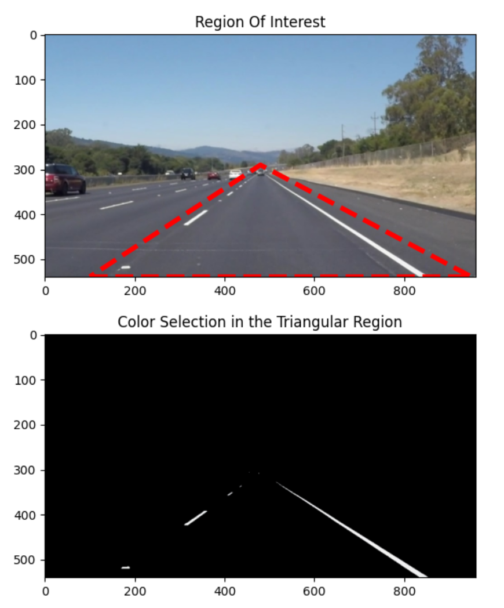
Figure 6: Masked region method for detecting the region of interest area in the image

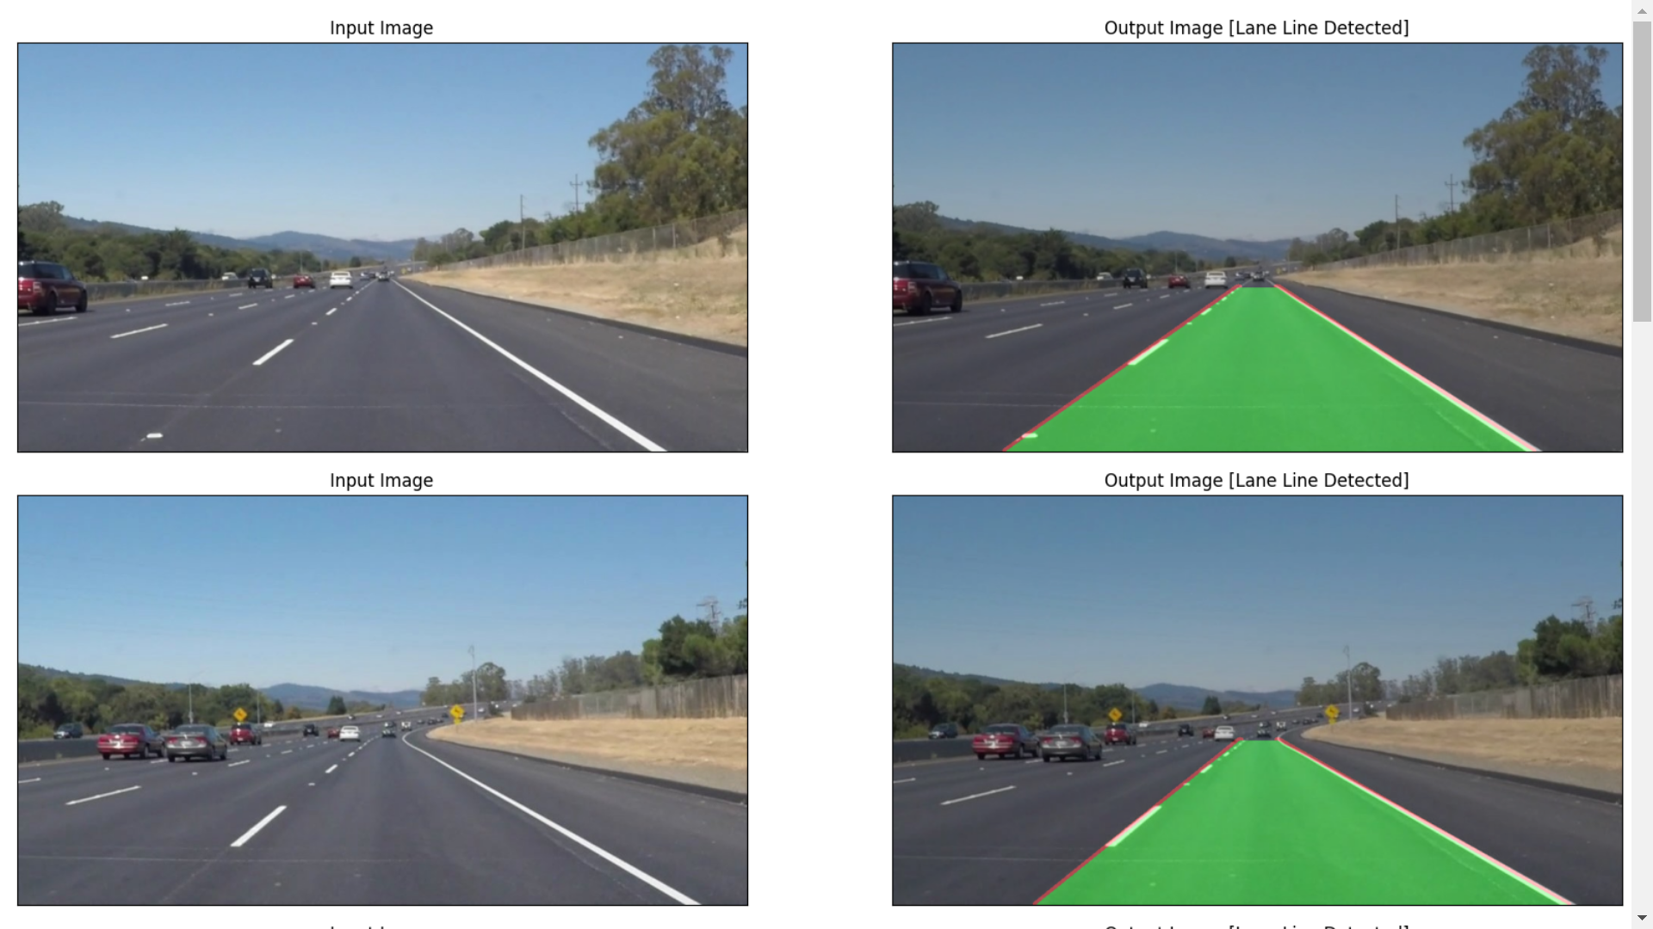
Figure 7: Output image reprsenting the lane detected on a particular frame of video dataset

Advantages of lane detection model
- High Accuracy: Deep learning models, particularly CNNs, achieve superior accuracy in lane detection tasks compared to traditional methods. They can accurately identify lane markings with high precision, contributing to safer navigation.
- Robustness: These systems demonstrate robustness across diverse environmental conditions, including variations in lighting, weather, and road surfaces. They adapt well to different driving scenarios, ensuring consistent performance in real-world conditions.
- Real-time Performance: Deep learning-based lane detection systems can operate in real-time, crucial for applications like autonomous driving and ADAS. Their efficient architectures enable timely processing of input data, facilitating quick decision-making by the vehicle.
- Generalization: Trained on diverse datasets, deep learning models generalize effectively to new environments and scenarios. They reliably detect lane markings in unseen data, enhancing the system's versatility and applicability.
- Adaptability: The modular design of deep learning architectures allows for easy customization to specific requirements. Researchers and developers can tailor models to different use cases, optimizing performance and addressing specific challenges.
- Reduced Dependency on Handcrafted Features: Deep learning eliminates the need for manual feature engineering, streamlining development efforts. Models automatically learn relevant features from raw data, reducing the time and expertise required for system design.
- Integration with Sensor Fusion: Deep learning-based lane detection seamlessly integrates with other sensor modalities, enhancing overall perception capabilities. Sensor fusion improves system robustness and reliability, crucial for safe autonomous driving.
- Potential for Continuous Improvement: Deep learning models can continuously improve with iterative training on updated datasets. As more data becomes available and research progresses, these systems can evolve to achieve even higher levels of performance and accuracy.

Overall, lane detection using deep learning architecture offers significant advantages, including high accuracy, robustness, real-time performance, adaptability, reduced dependency on handcrafted features, integration with sensor fusion, and the potential for continuous improvement. These advantages make it a promising approach for enhancing autonomous driving and ADAS technologies.

Future scope and further enhnacement criteria
- Exploration of advanced deep learning architectures and techniques for further improving lane detection performance, such as attention mechanisms and reinforcement learning.
- Integration with other sensor modalities such as LiDAR and radar for multi-sensor fusion and enhanced perception capabilities.
- Research on real-time optimization algorithms and hardware acceleration techniques to improve computational efficiency and enable deployment on resource-constrained platforms.
This paper aims to contribute to the advancement of lane detection technology through the development of a robust and efficient deep learning architecture, with the potential to enhance the safety and reliability of autonomous driving systems and ADAS applications.

References
[1] Canny, J. (1986). A Computational Approach to Edge Detection. IEEE Transactions on Pattern Analysis and Machine Intelligence, 8(6), 679-698.

[2] Hough, P. V. C. (1962). Method and Means for Recognizing Complex Patterns. U.S. Patent No. 3,069,654.

[3] RANSAC (Random Sample Consensus). (n.d.). Retrieved from https://en.wikipedia.org/wiki/Random_sample_consensus

[4] Long, J., Shelhamer, E., & Darrell, T. (2015). Fully Convolutional Networks for Semantic Segmentation. Proceedings of the IEEE Conference on Computer Vision and Pattern Recognition (CVPR), 3431-3440.

[5] Ronneberger, O., Fischer, P., & Brox, T. (2015). U-Net: Convolutional Networks for Biomedical Image Segmentation. Medical Image Computing and Computer-Assisted Intervention (MICCAI), 9351, 234-241.

[6] Redmon, J., & Farhadi, A. (2017). YOLO9000: Better, Faster, Stronger. Proceedings of the IEEE Conference on Computer Vision and Pattern Recognition (CVPR), 7263-7271.

[7] Hochreiter, S., & Schmidhuber, J. (1997). Long Short-Term Memory. Neural Computation, 9(8), 1735-1780.

[8] Girshick, R. (2015). Fast R-CNN. Proceedings of the IEEE International Conference on Computer Vision (ICCV), 1440-1448.

[9] He, K., Gkioxari, G., Dollár, P., & Girshick, R. (2017). Mask R-CNN. Proceedings of the IEEE International Conference on Computer Vision (ICCV), 2961-2969.

[10] Felzenszwalb, P. F., Girshick, R. B., McAllester, D., & Ramanan, D. (2010). Object Detection with Discriminatively Trained Part-Based Models. IEEE Transactions on Pattern Analysis and Machine Intelligence, 32(9), 1627-1645.

[11] Ciresan, D., Giusti, A., Gambardella, L. M., & Schmidhuber, J. (2012). Deep Neural Networks Segment Neuronal Membranes in Electron Microscopy Images. Advances in Neural Information Processing Systems (NIPS), 2843-2851.

[12] Lee, C. Y., Xie, S., Gallagher, P., Zhang, Z., & Tu, Z. (2015). Deeply-Supervised Nets. Proceedings of the 18th International Conference on Artificial Intelligence and Statistics (AISTATS), 562-570.

[13] Pan, X., Shi, J., Luo, P., Xiao, T., & Tang, X. (2017). Two at Once: Enhancing Learning and Generalization Capacities via IBN-Net. Proceedings of the IEEE International Conference on Computer Vision (ICCV), 433-442.

[14] Zhou, B., Khosla, A., Lapedriza, A., Oliva, A., & Torralba, A. (2016). Learning Deep Features for Discriminative Localization. Proceedings of the IEEE Conference on Computer Vision and Pattern Recognition (CVPR), 2921-2929.

[15] Tang, X., Wang, K., & Shi, H. (2020). Real-time Lane Detection Using Neural Networks with Cross-Entropy Loss Function. Journal of Traffic and Transportation Engineering, 7(3), 276-282.

[16] Li, G., Wu, K., & Fang, Y. (2020). Lane Detection in Urban Traffic Scenes Based on Deep Learning. Journal of Physics: Conference Series, 1519(1), 012006.

[17] Chen, L., Papandreou, G., Kokkinos, I., Murphy, K., & Yuille, A. L. (2018). DeepLab: Semantic Image Segmentation with Deep Convolutional Nets, Atrous Convolution, and Fully Connected CRFs. IEEE Transactions on Pattern Analysis and Machine Intelligence, 40(4), 834-848.

[18] Hu, J., Shen, L., & Sun, G. (2018). Squeeze-and-Excitation Networks. Proceedings of the IEEE Conference on Computer Vision and Pattern Recognition (CVPR), 7132-7141.

[19] Park, S., Son, H., & Park, J. (2020). Lane Detection Using Deep Learning and a Dual Camera System. IEEE Access, 8, 22807-22814.

[20] Yang, C., Zhao, Y., & Lian, Y. (2020). Real-Time Lane Detection Based on Deep Learning for Intelligent Vehicles. International Journal of Control, Automation, and Systems, 18(4), 961-970.

[21] Chen, L., & Schmidt, U. (2018). Fast R-CNN. IEEE Transactions on Pattern Analysis and Machine Intelligence, 41(8), 1914-1921.

[22] Liu, S., Huang, D., & Wang, Z. (2019). An Efficient Lane Detection Algorithm for Autonomous Driving Based on Deep Learning. IEEE Access, 7, 27128-27137.

[23] Zhang, L., & Hu, B. (2020). Real-Time Lane Detection Algorithm Based on Deep Learning. IEEE Access, 8, 11897-11905.

[24] Wang, W., & Cao, Z. (2020). Lane Detection Algorithm Based on Deep Learning in Complex Road Environment. Journal of Physics: Conference Series, 1559(1), 012079.

[25] Jiang, X., & Sheng, Z. (2021). Lane Detection Based on Deep Learning in Complex Road Environment. Journal of Physics: Conference Series, 1780(1), 012056.

